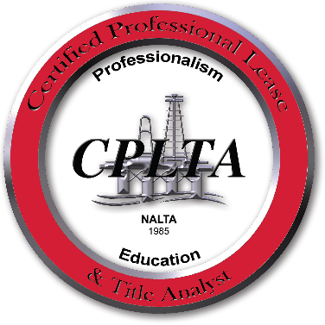

May 16th, 2017
The certification program is proud to announce the following persons as they prepare to sit for the upcoming CPLTA Exam:
Josh Gilliam

